Adeel Arshid

ECO 405-02

Prof. Holder

12/18/20

Final Paper

**Research Problem**

People of color tend to be poor in the United States.

**Research Question**

Does systemic racism contribute to poverty in Asian Communities?

**Hypothesis**

People of color are more likely to live in poverty because of systemic racism which limits their access to education and employment.

Abstract

*This paper will talk about different types of systemic racism that people in Asian American communities had faced. This paper will also focus on how those different types of racism lead Asian Americans to live in poverty in the United States. I will be looking at different source such as news articles, journal article and other sources to prove that systemic racism faced by Asian Americans will contributes towards them living into poverty. I think systemic racism does contributes towards poverty in Asian American communities. Since many of them are immigrants, there are tons of challenges and barriers they have to face while trying to achieve in the labor market. Factors such as English proficiency, healthcare and education all play a huge role that can make someone live in poverty and many Asian Americans had impacted by these barriers. When it comes to health insurance many Asian Americans are uninsured compared to other ethnic groups because of their job. Working mainly in service industries, they are less likely to receive health insurance through their employers and getting private health insurance would be costly, which their wage won’t be to cover it. I will also talk about current pandemic COVID-19 because Asians are facing many racial attacks towards them. For example, many Chinese business being target by people and misconception they have that they are the reason for the spread of COVID-19 pandemic. Many Asians owned business such hair salons and restaurants are being permanently closed, which will lead to unemployment for many people. I will take about racism and inequality that Asians Americans in the past when they first arrive in the United States. I will also present quantitative analysis that shows inequality and racism against Asian American, while discussing policy analysis that benefited Asian communities. In the end, I will try to present if I was able to prove or disprove my hypothesis.*

Racism has occurred in the United States throughout history and Asian Americans are one of the ethnic groups that have been targeted. Systemic racism creates inequality among different groups of people where some are at advantage while others are at disadvantage. Different types of systemic racism can impact Americans in many ways by creating gaps in wealth, education, employment, and healthcare. People of color like Asian Americans have been facing racism since the late 19th century because of their ethnicity, culture and economic success. Early Asian immigrants faced racism because of their economic success that created conflict between Native American groups and early Chinese settlers, who when they first arrived in the United States were targets of racism that made them live in poverty. The purpose of this paper is to prove that people of color such as Asian American are likely to live in poverty because of systemic racism which limits their access to education and employment.

Immigration plays a huge role that creates income inequality among Asian American. When the Immigration Act of 1990 was passed many Asian immigrants, who came to the United States who were highly educated, were unable to find jobs in high-skill occupations. Even though many contemporary Asian Americans are successful and have low poverty rates, there are Asian American communities that are still living in poverty. In early history Chinese Americans faced systemic racism which started in the mid-nineteenth century when they first arrived in California. Chinese immigrants started to arrive in America because of crop failures back home. They mainly worked in gold and silver mines, which the natives hated because they saw them as a threat to their livelihood. California also imposed a tax on foreign miners such as the Chinese which led to violence. I think is a type of discrimination because only foreign miner will pay the tax. During the recession of the 1870s, Chinese immigrants were blamed for the recession and that is where the anti-Chinese sentiment movement started. It also led to the passing of the Chinese Exclusion Act of 1882 which prevented Chinese immigrants from working in the labor market. Additionally, California’s government also imposed the Geary Act of 1892 which extended the ban on Chinese immigrants for another 10 years. Many Chinese immigrants did not have enough education and, therefore, they worked at low wage jobs. According to the journal article *“Standing Up Against Racial Discrimination: Progressive Americans and the Chinese Exclusion Act in the Late Nineteenth Century”* it states, “Since most of the early Chinese immigrants were young males with little education, they could only find employment in mines and railroad construction, and later as factory workers, agricultural laborers, fishermen, grocers, laundrymen and domestic servants” (p. 12)[1]. Many Chinese’s immigrants were uneducated and, therefore, were not able to find better, well-paying jobs. A person who is working a low paying job will see themselves in a tough financial situation. With low salaries, there are only limited things they can do when it comes down to their expenses. For example, if a person is working in factories or a domestic servant, those people could have hardship paying for health insurance or a better neighborhood to live in. Those people could end up living in poor neighborhood and in poverty because of less economic opportunities. *“The Color of Success: Asian Americans and the Origins of the Model Minority”* book by Ellen D. She talks about racism Chinese started to face when China entered the Korean War. Chinese living the United States experienced many physical as well harassment assaults towards them. Ellen D. Wu, (2013), *“The Color of Success: Asian Americans and the Origins of the Model Minority”* states, “Businesses reported losses as nervous clientele began canceling orders. Individuals became targets of verbal harassment and physical assaults, as was the case of one unfortunate Texan who was shot when mistaken for a “communist” (p. 112) [2]. I think even though it does not support how Asians living in poverty, but still shows that they are facing racism since 20th century.

In New York, the Asian population has grown ever since 2000, and they are one of the fastest growing groups of people in the United States. People see Asian Americans as hardworking and successful people who do not require help from the government. In reality, many Asian Americans are not as successful as people believe. In the article *“Researching Asian Poverty in New York”* author states, “The Asian American Federation reports that in 2014, the Department of Social Services provided an average of $600,000 to Asian American community-based organizations, while the average contract dollar amount they distributed to other affinity groups was $1.4 million”[3]. This shows that because of the model minority stereotype, Asians are being underrepresented in terms of being perceived as needing and receiving government and philanthropic assistance. Asian dominant communities such as Chinatown in New York City are places where many uneducated and immigrant Chinese workers find work because it requires little to no education to get a job. Most of the jobs in Chinatown are low paying jobs and many workers are barely making a living. For example, in 2017, the Asian Americans poverty rate in NYC was 23.8 compared to whites (12.6%), black (20.4%) and Hispanic (22.4%) (graph C). New York also is the most expensive state to live in. Housing is also a big problem that Asian Americans are facing. Most of their income would go towards paying rents because of high cost of living.

Asian Americans, among other minorities, live in poverty in the United States because of systemic racism. Even though Asian Americans are a model minority and people see them as successful; in reality there are Asian Americans who are living in poverty. Racism in the labor forces causes many Asian Americans to live in poverty. Many Asians struggle with language barriers and not speaking English, which limits their participation in the labor force. In “Unemployment lasts longer for Asian American” (2010) it states, “They are heavily reliant on employers from the same ethnic group, so if for some reason those jobs are no longer available, it is more challenging for those workers to find employment, given the language and cultural barriers they face”[4]. This is a form of racism because many employers would discriminate against Asian American who are not fluent in English, and that is why they would not be able to get hired. If they don’t find jobs, then there is chance of falling into poverty. In the Journal article “Poverty among Asian American in the 21st Century” (2011) author states, “Other studies have similarly found that educational degrees obtained from other foreign countries are typically heavily devalued in the American labor market” (P. 255)[5]. This shows that in the United States, many Asian American struggle to obtain a high-end job in the labor market but many hold foreign degrees and it is harder for them participate in the labor market because they are devalued by their employers. For example, if a person has a bachelor, masters or doctorate degree from Asia, he or she will still have difficult time find a found with those degrees compare to people with the same degree but they have attained it within the United States. This creates inequality among Asian Americans who have foreign degrees and they struggle to find better jobs in the American labor market. This may occur since many Asian American are not born in the United States and they have received their education abroad and employers in the U.S. labor market see that employees with foreign degrees may not have proper training or knowledge that makes them fit to be in the U.S. labor force. This is a type of discrimination that prevents Asian American to succeeding in the labor force. Also, in “Poverty among Asian American in the 21st Century” it states, “Prior studies find that educational degrees obtained from foreign countries are heavily devalued in the U.S. labor market” (p. 936)[6]. This proves that having foreign degree will be devalued in the United States. I think that since education system outside the United States are not really well developed so the employers will be hesitant hiring someone that does not have degree within the United States. If foreign born Asians hold a degree out of the United States, it will be difficult for them to find well-paying jobs. I have seen many people that have respected degree is certain field from their home country but working as a cab driver.

Among different Asian American communities there is education inequality. In 2017, 53% of Asian Americans had obtained bachelor's degrees. People migrating from developed Asian countries will achieve relatively higher education than people from still developing Asian countries which tend to have low education rates. In the article “Why Disaggregate? Big difference in AAPI Education” it states, “Just 1 in 4 Burmese Americans have a bachelor’s degree or higher compared to about 3 in 4 Taiwanese Americans and Indian Americans. Mongolian, Sri Lankan and Malaysian Americans have bachelor’s degrees with high rates, 59%, 57% and 55% respectively. On the other end, Bhutanese, Laotian and Cambodians have the lowest rates of attaining bachelor’s degrees, at 11%, 14% and 17”[7]. Asian Americans from still developing countries will struggle and face more challenges among their counterparts from developed countries. I think this can lead to discrimination in the workforce. Many employers will not offer jobs to people from poor countries because they will see them as uneducated people. Developing countries also have poor education system which can make someone from that country to be discriminated against by the U.S. employers. Many people come from poor countries to America to change their lives and make a better living, but racism will prevent them from achieving their goals. If employers discriminate against Asians based on their education, it can lead them into poverty because they can’t obtain a good high paying job or a career. They would most likely accept a low paying job and live paycheck to paycheck working at fast food or other jobs which does not require such of education.

Income inequality is one form of racism that causes many Asian Americans to live in poverty. Even though they may be well educated and have low unemployment, it is hard for some Asian American to return to the labor force once they have left the labor market. Many Asian American workers are living in poverty because of working minimum wage jobs. The main reason for this is because since Asians face challenges like language barriers, they would normally work a low-end job such as taxi driver, cashiers, construction workers, and retail salesperson. Income inequality prevents people from having proper economic opportunities. Low income not only affects a person as an individual but also prevents the economy from growing. Having low income impacted many Asians' standard of living compared to other ethnic groups.

Even though Asian Americans are the most educated group of people compared to other races, they still face income inequality in the labor force. In 2017, Asian Americans with education levels of less than high school diploma earned around $25,000, while whites earned $29,100. Even though Asian Americans and whites both had education of less than a high school diploma, whites are still better off than Asians. Asian Americans with high school diplomas would earn around $29,000, while whites with high school diplomas would earn $35,000. Asian Americans household income is greater than other races, but millions of Asians still suffer in poverty despite being successful. In the article “Racial Wealth Snapshot: Asian Americans And the Racial Wealth Divide” it states, “In 2018, 10.01%of Asian American lived in poverty, compared to 8.1% of whites, non-Hispanic Americans”[8]. This shows that inequality between Asian and whites that Asians would always have higher poverty rate compared to whites even in they are well and highly educated than them.

During the Covid-19 pandemic Asian Americans have faced many racially discriminatory acts. In the article “Many Black and Asian Americans Say They Have Experienced Discrimination Amid the COVID-19 Outbreak” is states, “About three-in-ten Asian Adult (31%) say they have been subjected to slurs or jokes because of their race and ethnicity since the outbreak began, compared with 21% of black adults, 15% Hispanic adults and 8% of white adults”[9]. This shows how Covid-19 had focused and raised the amount of racism against Asian Americans compared to other ethnic groups. Asian Americans are becoming more of an easy target to experience racism than before. The Covid-19 pandemic has affected many Asian businesses because of racial bias ever since President Trump began referring to Covid-19 as the China virus, blaming them for the outbreak. Similarly, “Asian Americans face dual challenges: Surging unemployment and racism” (2020) argues, “This is why racializing COVID-19 as ‘the China virus’ has profound societal repercussions. We have seen this in the increase in verbal and physical attacks on Asians and in the material ways in terms of joblessness and business failures”[10]. As the pandemic continues, there have been many hate crimes committed against Asian Americans. Many Asian American healthcare workers are facing discrimination. Many small businesses that Asian Americans own are at risk of shutting down because of discrimination. In the article “The invisible struggle of the Asian American small-business owner” (2020) author Nguyen states, “A UCLA study published in July indicates that as the virus began to progress in the US, the Asian American unemployment rate increased faster than that for white Americans, surging from around 3 percent in February - one of the lowest rates of any racial groups - to a whopping 15 percent in May this year”[11]. This shows Asian American workers were affected the most by the pandemic the most compared to white Americans workers.

Because of the COVID-19 pandemic half of the Chinese owned business have been permanently shut downed. They have been targeted because of prejudiced people have who believe that Chinese are the reason for this pandemic. While businesses were being shut downed, unemployment was increasing. Author Melany De La Cruz-Viesca, states, “By May 2020, the researchers found, the unemployment rate for Asians was 15% and the jobless rate was 21%, compared with 12% and 16% for whites”[12]. This shows inequality towards Asians because even though they are more educated, it still shows that Asian are working in industries that are very vulnerable. With the Asian Americans unemployment filing rate increasing, many will end up in massive debt or even fall into poverty if they are unable to pay their bills on time. For example, in New York more half of its population are renters, as for those who have lost their jobs and being able to pay their rent, they can become homeless at some point. Chinese Americans are mostly likely to own service related businesses such as hair salons and laundromats. Not just restaurants, other service related businesses that Chinese Americans own are seeing their businesses fail because of people's prejudice. In the article “Report shows major effects of COVID-19 on Asian American labor force” it explains, “The unemployment rate for Asian Americans in the hospitality and leisure sector in April was 39%, compared with 36% & for non-Hispanic whites. In the other services sector, the rate was 40% for Asians and 19% for whites”[13]. This also shows that during this pandemic, Asian Americans are facing the most amount of racism and discrimination towards them. Until misconception that people have towards Chinese exists, Asian Americans will continue to face discrimination. Some of the things that I think the government should do that could help Asian American that have lost their jobs is provide financial support. The government could also provide funding that can help small businesses that are not failing but struggling to remain open. Such as supporting local restaurants because they are the main target of COVID-19 pandemic.

The Covid-19 pandemic is not just impacting Asians in terms of racism and loss of employment, but also impacting people who have lost their jobs who are working in the United States on HB-1 visas. All Asians who are living in America on an HB-1 visa and have lost their jobs, they need to find another job that will sponsor their work visa in less than 2 months. After 2 months they will be considered living illegally in America. Another way they can obtain a visa to live in America legally is via student or tourist visas. According to the article “Chinese workers in the US are losing their visas with their jobs. But flying home to China is too expensive” it states, “I’ve never seen so many visa holders losing their jobs...It’s worst than in 2008”[14]. This Covid-19 has created massive unemployment compared to the 2008 financial crisis and leading thousands of Asian American unemployed working in restaurants. I see this as a discriminatory action because ever since COVID-19 is seen as Chinese virus, a lot of regulations are being enforced on Chinese people, such as banning incoming flights coming in from China. An Asian who has lost their job and lost HB-1 visas and is not able to find a new job and renew or obtain a visa eventually will be living illegally in America. If this happens, they would not have access to any government benefits or health insurance. It also leads them into poverty because they have no job or any other source of income. It will be difficult for them to support themselves and in the time of this pandemic poverty can fall upon them easily. People have fewer choices; living in poverty or going back home.

Asian Americans that have lost their jobs due to the pandemic will have tough time re finding a new job, it there only worked in restaurant. Now with the closure of restaurants those, people do not have experience to go and find work in different industries or sector of the economy. By losing their job, they have lost the health insurance if they used to get for their employer. This create financial burden on them if they ever need to seek medical help but won’t be able to because of how high medical bills are. My own assumption that, all those people will definitely fall into poverty because of no financial help and since they have no income to support themselves. As the rents are extremely high in some places, it could be difficult for them to pay rent. Their only option would be to go homeless shelter or move to cheap neighborhood.

Additionally, in the United States, many Asian Americans are facing racism in the healthcare sector. Mainly Caucasian have proper access to healthcare relative to people of color such as Asian Americans. Factors that prevent many Asian Americans from accessing proper healthcare include immigration status, language barriers and health literacy. Asian Americans have the fastest growing population in the United States. Language barriers is one type of issue that many Asian Americans face that prevents them from getting access to healthcare. In the journal article “Barriers to Healthcare Among Asian Americans'' it states, “Many Asian Americans who are not proficient in English experience barriers in help seeking, including making an appointment, locating a health facility, communicating with health professionals, and acquiring knowledge on illness” (p. 289)[15]. This shows a type of discrimination that Asian Americans experience because they do not have accessibility to proper services which can help them get access to healthcare. Many elderly Asian American have to rely on their family members to help with things that require speaking or understanding English**.** In the United States, not all ethnic groups have access to health insurance. Health literacy also contributes to Asian American living in poverty. Some Asian Americans have limited knowledge of health literacy preventing them from seeking the medical help they require. Many Asian American don’t receive health insurance from their employers because they work at low wage jobs. Not having access to health insurance can lead them to live in poverty because if they fall very ill and cannot go to work then they will earn less on their paycheck and they cannot afford to quit their job because it could be difficult for them to find new job with limited skill or experience they have. Only a limited number of Asian Americans are able to get full health insurance coverage from employers. Therefore, Asian American fell short in obtaining health insurance from their employers. Obtaining private insurance can also be difficult for them to obtain mainly because the premium price of those insurance will be very high, which they might be unable to afford. For example, it someone doesn’t have a health insurance, it can cost over $500 if they want to ER.

To undocumented Asian Americans, it is really difficult for them to have health insurance because they may not have proper documentation they need in order to apply for health insurance. It puts them at risk towards being uninsured if they fall ill, it will be hard for them to see a doctor and may end up losing their jobs if they feel really sick and unable to go to work, leading them into poverty. Even the many government assisted health provider, they still require proper documentation in order to apply for public health insurance. Other than health insurance, undocumented also other challenging like finding a well-paying job. Since they are undocumented, they will only be able to find work where the employers are willing to hire them and even offer them lower than minimum wage.

In the United States, there are more than 17 million Asian American according to the 2010 Census report. When Asian First arrived in the United States, they mainly worked in the agricultural sector and their population started to grow because of the 1965 Immigration act which allowed Asian from different countries for come into the United States. In the 2010 census, millions of the U.S. population did not participate. This prevented their communities from receiving federal funding that is needed to help their community to grow. Census statistics are used to provide federal funding that supports many health care programs as well as education programs. According to the article “2020 Census: What’s at Stake for Asian American and Pacific Islander” it states, “An accurate census is also essential for helping ensure that Asian Americans receive adequate political representation”[16]. This shows that Asian communities need proper representation in census so it can help their community to grow. Federal funding can help support various programs such as Medicaid, Medicare and Supplement Nutrition Assistance Program. It is important to receive federal funding because it can help eliminate poverty in many communities including Asian Americans community.

Inequality among the different Asian American groups is impacted by the amount of education they have and their English proficiency. In 2016 Chinese and Indians had higher income compared to their counterparts like people from Southeast Asian because they have more education. According to the article “How ‘Crazy Rich’ Asians Have Led to the Largest Income Gap in the U.S.” author states, “Southeast Asian groups from countries like Vietnam, Cambodia and Laos, however, lag well behind the average for other Asian Americans”[17]. This shows that people from developing countries that come into America, will struggle with language proficiency because of their lack of education. However, another key difference between Asian immigrants is that many arrived on a skill-based visa compared to immigrants who do not. The United States offers visas programs that help international students to work while they are attending college. Visa programs like HB-1 are used by immigrants that are highly skilled coming from Asian countries. Donald Trump wants to ban H-1B visas, including L-1 and J-1 visas. Which would prevent thousands of Asian immigrants from entering the U.S. and securing a future for themselves. Many large tech companies like Amazon and Google hire foreign workers from India and China. Trump wants American companies to hire American workers and not any foreign workers. This act could be seen as discriminatory because Trump is denying foreign workers to work in America. I think since Asian Americans are employed in big tech companies, they should fight on behalf of all those workers that are having difficult time renewing their HB-1 visas. The rate of H1-B that are given out every year has been declining over the course of years. This shows racism against Asian because they are being denied jobs in favor of American workers. For example, in 2019, majority of HB-1 visas were held by Indians and Chinese’s. If the H-1B visa ban takes effect, it will impact many immigrants who are already working in America.

In the wake of the COVID-19 pandemic, we have seen Chinese Americans facing racial attacks which now also includes thousands of Chinese international students who are living in America on student visas. President Donald Trump banned international students from coming into the United States and trying to send back Chinese international students that are already studying. I think the banning of Chinese students is a xenophobic attack that Trump took towards Asian Americans and their community. I could compare this to Chinese Exclusion Act because they both ban Chinese from entering the United States. It also shows that Trump is using China and the Chinese expatriates as a scapegoat by blaming them. Back when Trump placed an immigration ban on Muslim countries and now a ban on China, it shows how Asians are facing xenophobic attacks. The way I see it is that this Chinese ban can lead to poverty for Chinese American because, Chinese are coming to America for better education and to get out of poverty back home and students are getting their education in America because it is better and considered more valuable. If they are sent back, they will go back to live in poverty where they came from in the first place.

In 2010, Asian Americans had more higher education compared to whites but Asian Americans’ unemployment rate was still higher than whites. Racial bias in the labor market reduces employment opportunities for Asian Americans regardless of them having higher education. Even after the recession in 2010, Asian Americans were unemployed for the longest compared to Hispanics, whites and blacks. Also, in the same year, the unemployment rate of Asian Americans who hold a bachelor degree was 6.8%, while unemployment of whites that had the same education was 4.7% (Figure A). Even with obtaining an advanced degree, Asian Americans unemployment was higher than whites, at 3.7% compared to 3.2% (Figure A). For Asian Americans who had some college, their unemployment rate was 8.1% and whites with some college had an unemployment rate of 7.4% (Figure A). Asian Americans with less than a high school diploma had a lower unemployment rate at 10.9% while white workers had 15% (Figure A). This could be mainly because Asian Americans accept low paying jobs that white Americans refuse to take, and those jobs would be considered mainly for immigrants. Nativity also plays a crucial role in the unemployment rate. For example, many Asian Americans are foreign born compared to whites. Even having higher education than whites, Asian Americans unemployment would be higher. Racial bias is another reason why Asian Americans have higher unemployment while being better educated**.** During the recession between 2007 and 2010, Asian Americans had the highest unemployment rate compared to Hispanic, Blacks and whites. In the journal article “Asian Americans and Higher Education” author states, “Asian Americans with higher levels of education than whites tend to have lower levels of income and that many Asian American are underemployed relative to their qualification” (P. 368)[18]. Asian Americans will still face racism in the labor market even though they are more educated than their competitors, which just proves that they are facing racism in the labor market. Facing racism in labor markets increases their chance of being unemployed and not having a job will lead them into poverty. Without any source of income, many Asians will struggle from making a living and supporting their family.

Asian American faced many barriers that prevented them from accessing health insurance. One of the policies that was created to help Asian Americans gain access to health insurance was the Affordable Care Act. The purpose of this policy was to give all Americans access to healthcare that they can easily afford. Asian American struggled to access health care because of inequality and disparities. The Affordable Care Act was a successful policy because its uninsured rates of Asian Americans declined and reduced the coverage gap between Asian Americans and the whites. Jesse C. Baumgartner (2020) states in an article from The Commonwealth Fund that “By 2017-2019, Asian Americans had the lowest uninsured rate of any racial or ethnic group in the U.S. Uninsured rates have fallen among all Asian American subgroups since the passage of the ACA, but not uniformly”[19]. This shows how the Affordable Care Act helped Asian Americans ethic groups to receive health insurance that they could not have before. Before the Affordable Care Act was passed, working-age Asian Americans were relatively more uninsured compared to whites, but well off compared to Blacks and Latinos. In 2010-2011, 19.5% of Asian Americans were uninsured while whites’ rate was only 15.3%. Over the years the uninsured gap between Asian Americans and whites started to disappear. In 2017-2018, only 7.9% of Asian American were uninsured compared to 8.5% of whites being uninsured (Graph B). There are many subgroups in the Asian American population that cannot get access to health insurance because of many immigration policies. If they are undocumented immigrants, then their fear of being deported which prevents them from acquiring health insurance. While for the other all Americans including Asian, Affordable Care Act was a successful policy that helped millions of people to receive healthcare if they were unable to receive from their employer.

The purpose of this paper was to prove how systemic racism causes Asian Americans to live in poverty. Asian Americans face racism in the labor market which limits their access to high paying jobs. Furthermore, Asian Americans also face systemic racism in education, health care, and experienced income inequality even though many of them are well educated. I still believe that even if Asians achieve higher education compared to other races, they will still experience systemic racism which leads them into poverty. During this COVID-19 pandemic, Asian Americans have been negatively affected. People discriminate against Chinese businesses like restaurants, which caused many long-standing Chinese-owned restaurants to close down permanently. With the travel ban on Chinese during COVID-19 pandemic, President Donald Trump made a racial attack towards and blaming them for the cause of the pandemic. Even though they have higher education, they would still face discrimination in the labor market causing them to lack behind in employment. Many Asian also face challenging barriers that can cause language that prevented them from fully participate in the labor force. Asian Americans also lacks of having a proper health insurance of their low paying job. Many would be depended on having health insurance from the government, but I they are undocumented it will be more challenging for them to acquire health insurance. After looking at different source and journal article and quantitative analysis, I have proven that my hypothesis about systemic racism playing a role in that cause Asian American to live in poverty is true.

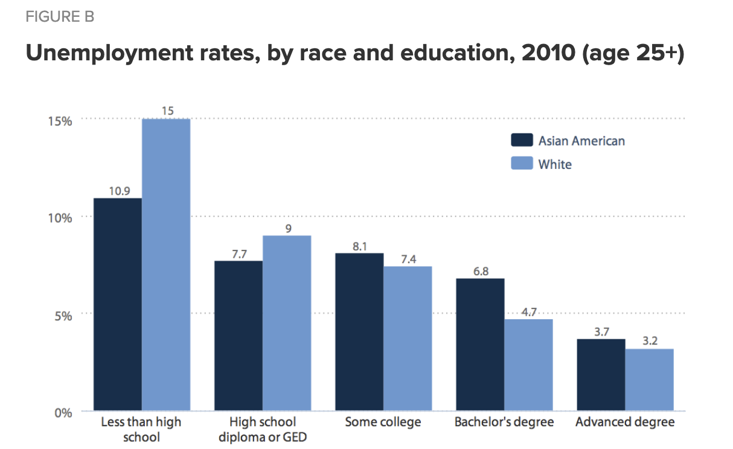

**Graph A**

Kim, M. (2012). *Figure B Unemployment rates, by race and education, 2010 (age 25+).* [Graph]. Economic Policy Institute. <https://www.epi.org/publication/ib323-asian-american-unemployment/>

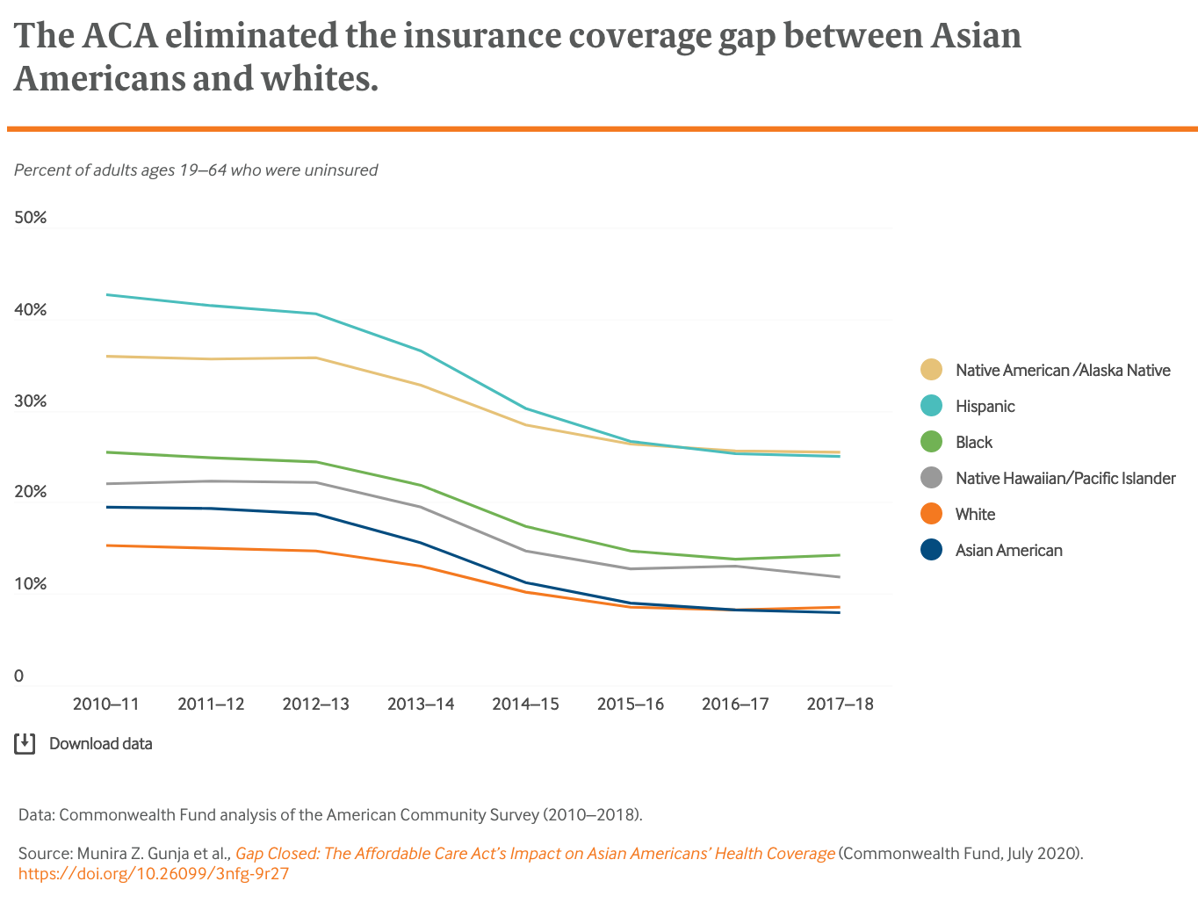

**Graph B**

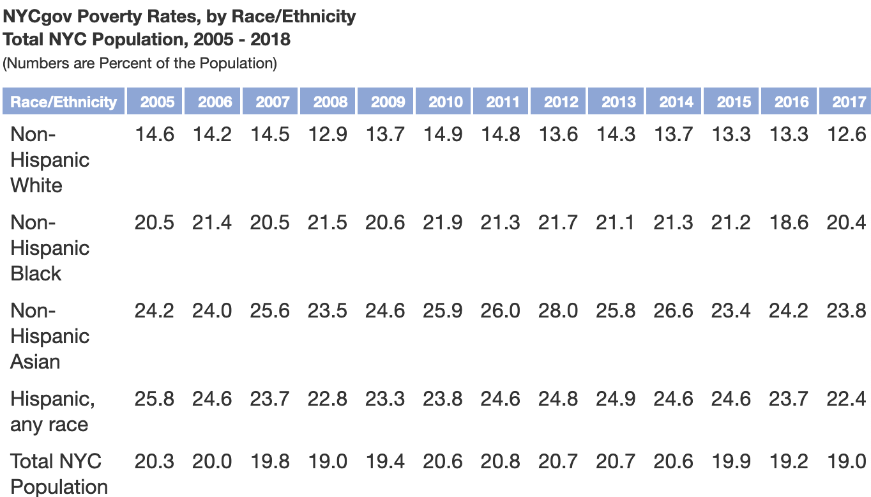

**Graph C**

The Mayor’s Office for Economic Opportunity (2020*). NYCgov Poverty Rates, by Race/Ethnicity. Total NYC Population, 2005 – 2018*. [Graph]. <https://www1.nyc.gov/site/opportunity/poverty-in-nyc/data-tool.page>

Annotated Bibliography

Wu, Ellen D. *The Color of Success: Asian Americans and the Origins of the Model Minority.* Princeton, New Jersey: Princeton University Press, 2014. Print.

This book will help me with my research because it talks about racism than Chinese were facing during Korean war. Especially in Chapter 4 of this book when china entered the Korean War. Chinese that were living in the United States at that time saw physical assaults towards then because people saw them as their enemy.

Zhang, Wenxian (2019). “Standing Up Against Racial Discrimination: Progressive Americans and the Chinese Exclusion Act in the Late Nineteenth Century.” *Phylon*, vol. 56, no. 1, pp. 8–32. Retrieved from JSTOR.

This journal article will help me in the research paper because it talks about early Chinese immigrants that arrived in California and racism that they faced by the native. It created competition between them because of Chinese immigrants' economic success. It also led to Chinese Exclusion Act of 1882 which prohibited Chinese immigrants from entering the United States and working.

Takei, Isao, and Arthur Sakamoto (2011). “Poverty Among Asian Americans in the 21St Century.” *Sociological perspectives*. Retrieved from JSTOR.

This article talks about how Asian American have disadvantage in society because of discrimination. Language barriers also prevent many Asian American from getting a high-end job because they don’t speak fluent English. In the United States, many foreign degrees are devalued which prevent people from getting a good job, therefore many have to take low end paying jobs which can lead them to live in poverty.

Kim, ChangHwan, and Arthur Sakamoto (2010). “Have Asian American Men Achieved Labor Market Parity with White Men?” *American sociological review* 7. 934–957.

This Journal Article will help in my research because it talks about how Asian Americans face discrimination in the labor market. Asian American don’t have the same socioeconomic opportunities as whites such as having enhanced college admissions, favored job interviews and better career opportunities. Asian Americans have higher education but the labor market still discriminates against them. Asian Americans need to invest heavily in human capital if they want to receive an equal amount of socioeconomic status as whites, if not they will be at the same level of blacks and Hispanics.

Yishiko, Caitlin (2020). Asian Americans face dual challenges: Surging unemployment and racism. Retrieved from<https://www.nbcnews.com/news/asian-america/asian-americans-face-dual-challenges-surging-unemployment-racism-n1235356>

This new article talks about how during the COVID-19 pandemic, racism against Asian American increased. In California, 83% of Asian American with high school diplomas filed for unemployment. Ever since July 2020, Asian American are facing racial bias incidents.

Gandel, Stephen (2020). Asian Americans are falling behind White workers in the job market. Retrieve from<https://www.cbsnews.com/news/asian-americans-unemployment-rate-august-jobs-report/>

This news article talks about how Asian American are heavily impacted by the pandemic compared to white workers in the job market. According to BLS, during the pandemic Asian Americans unemployment rate is 10.7% and 7.3% for whites. President Trump calling Covid-19 a Chinese virus has people being racist towards Asian American.

Starkey, Brando (2016). Why we must talk about the Asian-American story, too. Retrieved from<https://theundefeated.com/features/why-we-must-talk-about-the-asian-american-story-too/>

This article will help me in the research paper because it talks about early Asian American immigrants that arrived in the United States. Chinese immigrants arrived in 1849 to California to work. It created tension between Chinese and the native’s whites because Chinese immigrants were being a threat to their economy. Article also talks about how Asian American face discrimination in workplace and not being able to get high ranking position.

Wooksoo Kim & Robert H. Keefe PhD and ACSW (2010) Barriers to Healthcare Among Asian Americans, Social Work in Public Health, 25:3-4, 286-295.

This article is helpful because it talks about types of barriers that Asian Americans have to face that prevent them from getting healthcare. Some of the barriers including language/culture and immigration status.

Kim, C., & Sakamoto, A. (2010). Have Asian American Men Achieved Labor Market Parity with White Men? *American Sociological Review,* *75*(6), 934-957. Retrieved from <https://www.jstor.org/stable/25782173?seq=1>

This journal article will be useful for my research because it talks about racism that Asian American in labor market. For example, how foreign degrees are devalued in U.S. labor market. It also talks about model minority myths about how Asian are seen as a successful group of people but still there are poor Asian American that still exist.

Nguyen, Frances (Oct 29, 2020). *The invisible struggle of the Asian American American small-business owner*. Vox.com. Retrieved from <https://www.vox.com/21536943/asian-american-restuarant-racism-coronavirus>

This article talks how Asian Americans and other people of color faced racism during covid-19 pandemic. It also talks about how Asian businesses have been affected by the pandemic and racism against them making them go out of business.

Kim, Wooksoo (May, 2010). *Barriers to Healthcare Among Asian Americans*. Retrieved from<https://www.tandfonline.com/doi/pdf/10.1080/19371910903240704?needAccess=true&>

This journal article talks about barriers that Asian Americans face in health care sector. Also, how it affects them from not getting health insurance. Many Asian Americans work in low wage jobs which don't offer health insurance. Barriers like language, immigration status, health literacy affected their capability to get proper healthcare.

Lu, S. (2020). Chinese workers in the US are losing their visas with their jobs. But flying home to China is too expensive. CNN News. <https://www.cnn.com/2020/04/08/business/china-us-coronavirus-workers-intl-hnk/index.html>

This new article will be helpful to my paper because it talks about racism that Chinese are facing because of travel that is imposed by the President Trump. It also shows making Chinese students from China to go back home, but many can’t afford to do so because of the COVID-19 pandemic.

1. Zhang, Wenxian (2019). “Standing Up Against Racial Discrimination: Progressive Americans and the Chinese Exclusion Act in the Late Nineteenth Century.” *Phylon*, vol. 56, no. 1, pp. 8–32. Retrieved from JSTOR.
2. Wu, Ellen D. *The Color of Success: Asian Americans and the Origins of the Model Minority*. Princeton, New Jersey: Princeton University Press, 2014. Print. Retrieved from <https://ebookcentral.proquest.com/lib/johnjay-ebooks/reader.action?docID=1458381>
3. Sabrina Song (December 9, 2019). Researching Asian Poverty in New York. Retrieved from <http://www.roosevelthouse.hunter.cuny.edu/?forum-post=researching-asian-poverty-new-york>
4. Alana Semuels. (Sep.7. 2010). “Unemployment lasts longer for Asian American. <https://www.latimes.com/archives/la-xpm-2010-sep-07-la-fi-asian-jobless-20100907-story.html>
5. Takei, Isao, and Arthur Sakamoto (2011). “Poverty Among Asian Americans in the 21St Century.” *Sociological perspectives*. Retrieved from JSTOR.
6. 926
7. Shah, S., & Ramakrishan, K (2017, April 24). Why Disaggregate? Big Differences in AAPI Education. <http://aapidata.com/blog/countmein-aapi-education/>
8. Muhammad, D., Sim, S (May 14,2020). Racial Wealth Snapshot: Asian Americans And The Racial Wealth Divide. <https://ncrc.org/racial-wealth-snapshot-asian-americans-and-the-racial-wealth-divide/#_ftn7>

  
9. Ruiz, N., Horowitz, J., and Tamir, C. (July 1, 2020). Many Black and Asian Americans Say They Have Experienced Discrimination Amid the COVID-19 Outbreak. <https://www.pewsocialtrends.org/2020/07/01/many-black-and-asian-americans-say-they-have-experienced-discrimination-amid-the-covid-19-outbreak/>
10. Yoshiko, C. and Yam, K. (July 31,2020). Asian Americans face dual challenges: Surging unemployment and racism. <https://www.nbcnews.com/news/asian-america/asian-americans-face-dual-challenges-surging-unemployment-racism-n1235356>
11. Nguyen, F. (October 29, 2020). The Invisible struggle of the Asian American small-business owner. <https://www.vox.com/21536943/asian-american-restuarant-racism-coronavirus>
12. Cruz-Viesca, M. Report shows major effects of COVID-19 on Asian American labor force. <https://newsroom.ucla.edu/releases/report-shows-major-effects-of-covid-19-on-asian-american-labor-force>
13. Ibid.
14. Lu, Shen. (April 9, 2020). Chinese workers in the US are losing their visas with their jobs. But flying home to China is too expensive. <https://www.cnn.com/2020/04/08/business/china-us-coronavirus-workers-intl-hnk/index.html>
15. Wooksoo, Kim. (2010) Barriers to Healthcare Among Asian Americans, Social Work in Public Health, 25:3-4, 286-295. <https://www.tandfonline.com/doi/pdf/10.1080/19371910903240704?needAccess=true&>
16. Lau, Tim. (April 2, 2020). 2020 Census: What’s at stake for Asian Americans and Pacific Islanders. <https://www.brennancenter.org/our-work/analysis-opinion/2020-census-whats-stake-asian-americans-and-pacific-islanders>
17. Aubrey, Carlsen. (Aug. 17, 2018). How ‘Crazy Rich’ Asians Have Led to the Largest Income Gap in the U.S. <https://www.nytimes.com/interactive/2018/08/17/us/asian-income-inequality.html>
18. Endo, Russell. "Asian Americans and Higher Education." *Phylon (1960-)* 41, no. 4 (1980): 367-78. Accessed December 17, 2020. doi:10.2307/274861. <https://www.jstor.org/stable/274861>
19. Baunmgartner, J. (2020). *Gap Closed: The Affordable Car Act’s Impact on Asian Americans’ Health Coverage*. The Commonwealth Fund. Retrieved from <https://www.commonwealthfund.org/publications/issue-briefs/2020/jul/gap-closed-aca-impact-asian-american-coverage>.